Video Analytics

Reporting Portal

Introductory Tutorial

Contents
Video Analytics 1
Reporting Portal 1
Introductory Tutorial 1
1 Introduction 3
2 Getting Started 3
3 The Dashboard 3
Content Summary Statistics 3
Content Bounce Rate vs 75% Complete 3
Top Content Stream Views for Unique Browsers 3
Top Content Categories 3
Top Content 3
Top Referring Domains 3
Top Pages 3
4 Short Clip Video Title Drilldown 3
Selection Criteria Filter 3
Video Title Information 3
Stream Views for Unique Browsers 3
Average Time Spent Viewing 3
Content Bounce Rate vs 75% Complete 3
Audience Drop Off 3
5 Long-Play Video Title Drilldown 3
Selection Criteria Filter 3
Video Title Information 3
Stream Views for Unique Browsers 3
Average Time Spent Viewing 3
Content Bounce Rate vs 75% Complete 3
Video Chapter Breakdown 3
6 The Content Tab 3
Selection Criteria Filter 3
Content Summary Statistics 3
Stream Views for Unique Browsers 3
Top Content Titles 3
Top States/Regions 3
Other reports accessible via the Content Tab……. 3
7 The Advertising Tab 3
Selection Criteria Filter 3
Content Summary Statistics 3
Stream Views for Unique Browsers 3
Top Advertising Titles 3
Advertisement Performance on Content Categories 3
Top States/Regions 3
Other reports accessible via the Advertising Tab……. 3
8 The Demographics Tab 3
Selection Criteria Filter 3
Gender 3
Income 3
Age 3
Race 3
9 The Search Tab 3

1 Introduction

Video Analytics offers a hosted service and back-end data warehouse to capture and analyze each video event once viewers press play. The service helps clients make decisions on how to optimize and better monetize video content and ad campaigns. The results are compiled into a wide range of reports, including but not limited too; average viewing time, interval analysis and audience drop-off. Unique to Video Analytics is an Attentiveness Score, a single number measuring the overall quality of viewers’ experiences with a particular video, ad or ad/content interaction.

Video Analytics reports provide a wide array of analytics on content and ad performance over an
entire site. Clients can receive static reports, perform ad hoc analysis (interactive queries and
drill-downs) and export data. We provide filters to combine (or separate) ads and content as well as the capability to synchronize reports (like Audience Loss) with the relevant video.

2 Getting Started

Video Analytics is available via the VideoCensus or SiteCensus reporting portal. Once enabled for the Video Analytics service, and logged into your Census account, you can simply click the tab labeled Video Analytics and seamlessly view your data

3 The Dashboard

The Dashboard (Figure 1) provides an overview of video asset performance across your website.
It gives you a quick indication of any issues that need immediate attention. Key components of
the Dashboard are labeled in the picture below and described thereafter.

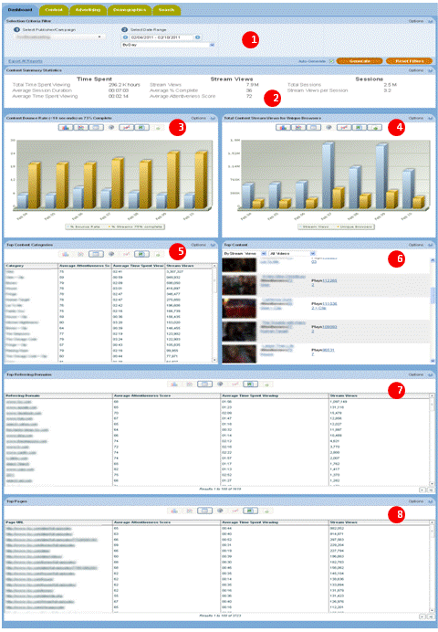
Figure 1: Dashboard

Selection Criteria Filter
The Selection Criteria Filter panel at the very top of each portal page gives you a detailed way to analyze your video content and ad performance.
Most of the filter choices are in drop-down lists, indicated by a downward arrow to the right of the selection. Date selections will pop up a calendar when you click on the date range text box. Once you have selected the filter lists, then press the Generate Report button at the bottom right-hand side to view the results. Individual filter descriptions are as follows:

Select Publisher/Campaign
This filter (Figure 2) allows you to select the Publisher/Campaign ID that you wish to see reports for. At the roll up level you can select a brand level and click it. In this case there are seven brands and we will click the first one.

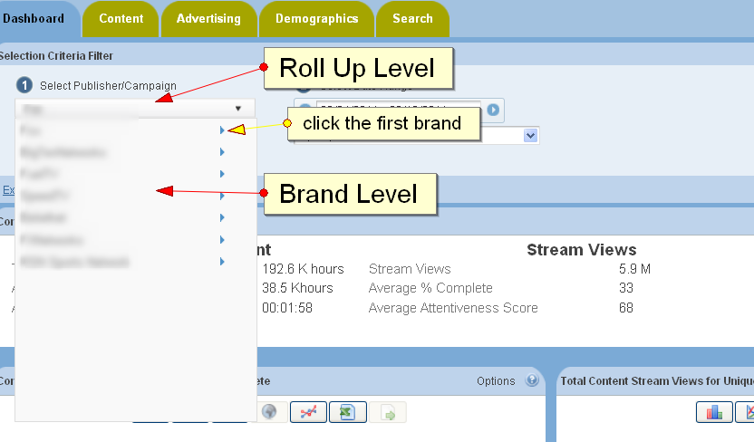
Figure 2: Roll Up and Brand Level

After we clicked the first brand we can take a look at the channel level (Figure 3). In this case there are four channels. You can select any channel to generate report or you can select the brand name (bold fond) which is the sum all four channels.
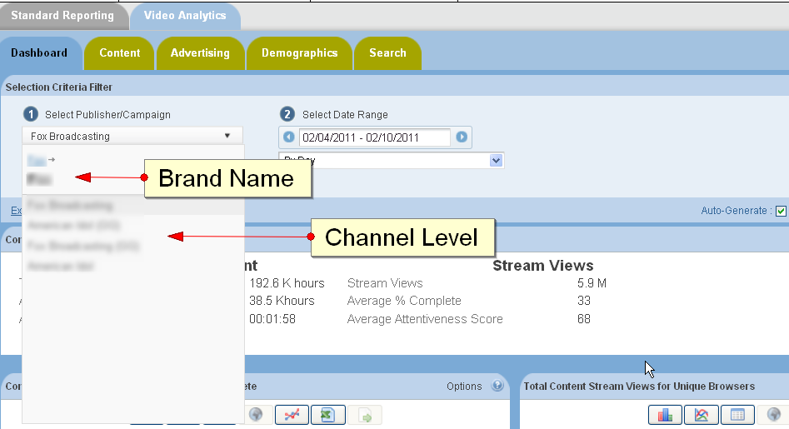
Figure 3: Channel Level

Select Date Range
This filter allows you to pick the time period that you are interested in analyzing. Click on the date range text box to interactively select a calendar date range. Once the date range is selected, then you can also select a time unit to let you see the charts by Hour, Day, Week, Month, or other interval. “By Hour” time selection is only available in the Dashboard, not in the Content Tab or Ad Tab at the roll up level.

Excel Export
Excel Export allows you to extract the data in the reports into an Excel Spreadsheet. "Export All Reports" extracts data from every section of the report, and inserts it into separate Tabs in the spreadsheet. The data is truncated to 500 rows on each Tab. An "Export Data" icon is available for each chart, grid, or statistics section. The data is truncated to 32k rows on the individual sections, and it may take a while to return if it is especially large. If have data sets on individual reports which exceed 32K rows please contact your Nielsen Account Manager, who will be happy to assist you with this.
Note: Filter settings are 'sticky' by design. i.e. setting the filter in the content area to filter on a particular video asset will be carried across to the advertising area. Likewise, a date range will be carried across between areas.

Content Summary Statistics
This report displays summary level statistics for your video content in the areas of Time Spent, Stream Views, and Sessions:

Time Spent Viewing
The amount of video viewed at normal speed in seconds or other appropriate time-based units; if a rewind event occurs during play, Time Spent Viewing may be calculated on total amount of video viewed at normal speed (i.e. including additional amounts of video viewed after rewind.)

Average Session Duration
The average time spent watching one or more videos on a site during a single Viewing Session in seconds. A viewing session is defined as a period of interaction between a visitor's browser and a particular video site, ending when the browser is closed, the user navigates away, or when the user has remained on a site but not had any streaming activity for a 30 minute period of time.

Average Time Spent Viewing
The Total Viewing Time divided by the total number of Stream Views in seconds.

Stream Views
The total number of videos viewed.

Average Exposure
The average number of times a viewer is exposed to a video or ad. Average Exposure gives you an indication of how effective your videos are or how well your ad campaign is progressing. It can also be used to adjust an ad serving policy, if an ad is being seen too frequently (or not enough).

Average % Complete
The average percentage of video viewed continuously at normal speed. If a rewind event occurs during play, percent complete may be calculated on total amount of unduplicated video viewed at normal speed. Each section of video may only be considered once in the calculation. This definition governs the triggering of any “partial play” metrics, such as the common quartile percentages (25%, 50%,75%). Specifically, any partial play reporting must be based on the trigger being activated based on normal viewing speed.

Average Attentiveness Score
The Attentiveness Score provides a single, comprehensive number to measure how your videos are performing. We weight factors such as how long the viewer has watched the video, whether the video or ad is viewable (in focus) by the viewer, and other positive events like turning up the sound, and making the video full screen. We also adjust Attentiveness to account for viewer loyalty (repeat views by the same viewer). The score is a number from 1 (lowest Attentiveness) to 100 (highest Attentiveness).

Total Sessions
A viewing session is defined as a period of interaction between a visitor's browser and a particular video site, ending when the browser is closed, the user navigates away, or when the user has remained on a site but not had any streaming activity for a 30 minute period of time.

Unique Browsers
Unique Browsers are the number of individual visitors that have started a video. (a) In the Summary Statistics at the top of each Report Tab, Unique Browsers are the number of individuals that have viewed a video at least once during the Date Range in the filter. Whether the individual viewer visited 1 time or one 100 times during the Date Range, they will only be counted as one Unique Browser (b) In the detailed Charts (like Stream Views for Unique Browsers) Unique Browsers are the number of individuals that have viewed a video at least once during the time interval in the Date Range. For example, if the Stream Views for Unique Browsers report Date Range is the 1st to the 7th, By Day, the Unique Browsers are the individual visitors counted each day. If a viewer has visited 7 days in a row, they will be counted once each day in the Stream Views

Sessions per Unique
Viewing Sessions divided by the number of Unique Browsers.

Stream Views per Session
Stream Views divided by the number of Viewing Sessions.

Content Bounce Rate vs 75% Complete
Bounce Rate and Complete Views is a composite chart to let you know where and when your viewers are leaving the videos. The first bar is the Bounce Rate, the percentage of viewers who leave the video within the first 10 seconds. The second bar shows the viewers who complete 75% or more of the video.
- Moving your mouse over a data point or bar in a chart will pop up the detail for that point.
- Clicking on a data point or bar in a chart (or on a row in the List view) will drill down to the next level of detail; for example, clicking on a data point for a day will drill down to the hours within that day.
- To go back to the Category or Subcategory, click on the link in the "Path:" above the chart.

Top Content Stream Views for Unique Browsers
Stream Views shows the total number of times a video has been started. Unique Browsers are the number of individuals, with distinct browsers, that have started a video at least once during the time interval in the Date Range. For example, if a viewer has visited 7 days in a row, they will be counted once each day in a daily Stream Views chart. Stream Views is always higher than (or equal to) Unique Browsers, as a visitor will often play multiple videos. Note that the sum of these data points will differ from the number of unique browsers in the Content Summary Stats, which is de-duped over the entire period, rather than by unit of drill down (as is the case here).
- Moving your mouse over a data point or bar in a chart will pop up the detail for that point.
- Clicking on a data point or bar in a chart (or on a row in the List view) will drill down to the next level of detail; for example, clicking on a data point for a day will drill down to the hours within that day.
- To go back to the Category or Subcategory, click on the link in the "Path:" above the chart.
- Clicking on an Hourly data point will drill across to a Reach Breakdown report with other information related to Reach for that Day.

Top Content Categories
Top Content Categories shows the most popular content categories sorted by Stream Views (default). You can resort the list by clicking on any one of the column headers for Category, Average Attentiveness, Average Time Spent Viewing, Stream Views and Unique Browsers.
- Clicking on a row in the Category list will drill down to the Subcategories within the category.
- Clicking on a Subcategory will drill down to the individual Titles within the subcategory.
- To go back to the Category or Subcategory, click on the link in the "Path:" above the column headers.
- Clicking on a title will drill across to a Content Detail report with all other information related to that video.

Top Content

Top Content shows the most popular content titles sorted by Reach (default.) You can resort the list by Attentiveness or Attentive Reach by selecting those options from the drop-down list at the top of the report. Attentive Reach is calculated by multiplying Reach by Attentiveness as a percentage. It can help you understand if a video with limited reach may still be very valuable to a subset of your viewers.

You can also click the links within the video information area to display more detailed reports on that video.

Top Referring Domains
Referring Domains shows the top referring web sites to your site sorted by Stream Views (default). This shows the web site that the viewer was on before they watched your video. It helps you understand not only which sites are referring the most traffic to your site, but which sites are referring the viewers that are the most highly engaged. You can resort the list by clicking on any one of the column headers for Referring Domains, Average Attentiveness, Average Time Spent Viewing, Stream Views and Unique Browsers.

Top Pages
Top Pages shows the top pages on your site in which your video content appeared, sorted by Stream Views (default). It helps you understand not only which sections of your site are seeing the most video traffic but also whether particular sections deliver a more attentive audience. You can resort the list by clicking on any one of the column headers for Page URL, Average Attentiveness, Average Time Spent Viewing, Stream Views and Unique Browsers.
The ability to sort by column heading within tables is restricted to sorting the 100 entries which are currently in view (not the entire data set). The table in the UI surfaces the top 500 entries total spread across 5 different table tabs. If the data set is larger than 500 this can be accessed by hitting the Export Data button above the table. If you believe that the data set has more than 32,000 rows please contact your account manager who can request custom exports to account for this volume of data.

4 Short Clip Video Title Drilldown
Now that you have an overview of the types of macro-level information presented in the Dashboard, please scroll down the list of Top Content and choose an individual video. There are two types of videos, clip and episode. Once you click on the link of clip, you will be taken to a micro-level view of that short clip video title as shown below (Figure 4.) Key components of this report set are labeled in the picture below and described thereafter. Long- play video title drilldown is listed and described in the consequent section.

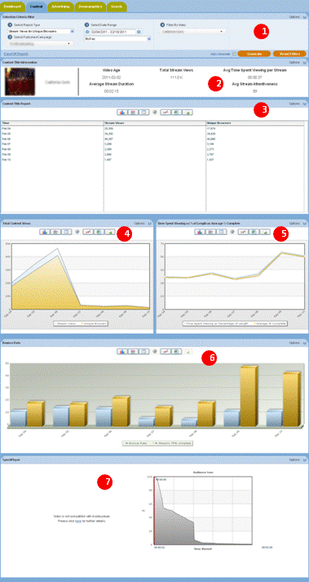
Figure 4: Short ClipVideo title information in the Content Tab

Selection Criteria Filter
The Selection Criteria Filter panel at the very top of each portal page gives you a detailed way to analyze your video content and ad performance.
Most of the filter choices are in drop-down lists, indicated by a downward arrow to the right of the selection. Date selections will pop up a calendar when you click on the date range text box. Once you have selected the filter lists, then press the Generate Report button at the bottom right-hand side to view the results. Individual filter descriptions are as follows:

Select Report Type
This filter allows you to select the report type that you wish to see.

Select Publisher/Campaign
This filter allows you to select the Publisher/Campaign ID that you wish to see reports for.

Select Date Range
This filter allows you to pick the time period that you are interested in analyzing. Click on the date range text box to interactively select a calendar date range. Once the date range is selected, then you can also select a time unit to let you see the charts by Day, Week, Month, or other interval.

Filter By Video
This filter allows you to select an individual video and or ad to run reports for. Video content has many different ways of being categorized. For example, a TV show might be organized by Show, then by Season, then by episode. Or TV shows could be categorized by Action, Drama, and Comedy. Nielsen can work with you on how to categorize your content (and Ads) to best represent how you are organized. Once the content is categorized, you can filter all the way down to an individual video or ad. The way Ads are categorized and filtered is very similar to video content. A powerful aspect of the Nielsen reporting system is the ability to see how ads perform against video content, an area we call ad/content interaction.

Excel Export
Excel Export allows you to extract the data in the reports into an Excel Spreadsheet. "Export All Reports" extracts data from every section of the report, and inserts it into separate Tabs in the spreadsheet. The data is truncated to 500 rows on each Tab. An "Export Data" icon is available for each chart, grid, or statistics section. The data is truncated to 32k rows on the individual sections, and it may take awhile to return if it is especially large. If have data sets on individual reports which exceed 32K rows please contact you Nielsen Account Manager, who will be happy to assist you with this.

Video Title Information

This report displays a set of high level stats for an individual video title which includes its Duration, the date that the video was first published, the number of times it was viewed, the number of Unique Browsers, Average Percent Viewed and Average Attentiveness.

& Stream Views for Unique Browsers
Stream Views shows the total number of times a video has been started. Unique Browsers are the number of individuals that have started a video at least once during the time interval in the Date Range. For example, if a viewer has visited 7 days in a row, they will be counted once each day in a daily Stream Views chart. Stream Views is always higher than (or equal to) Unique Browsers, as a visitor will often play multiple videos. Note that the sum of these data points will differ from the number of unique browsers in the Content Summary Stats, which is de-duped over the entire period, rather than by unit of drill down (as is the case here).

- Moving your mouse over a data point or bar in a chart will pop up the detail for that point.
- Clicking on a data point or bar in a chart (or on a row in the List view) will drill down to the next level of detail; for example, clicking on a data point for a day will drill down to the hours within that day.
- To go back to the Category or Subcategory, click on the link in the "Path:" above the chart.
- Clicking on an Hourly data point will drill across to a Reach Breakdown report with other information related to Reach for that Day.

Average Time Spent Viewing
This report compares the average time spent viewing (including seek backs) as a percentage of overall duration versus the percent complete of a video based on seconds watched. Note that the average time spent viewing can be greater than 100% since a given segment may be watched more than once. Also note that percent complete counts any given second of video play only once. So it is a video's viewing time but not including seek backs.

Content Bounce Rate vs 75% Complete
Bounce Rate and Complete Views is a composite chart to let you know where and when your viewers are leaving the videos. The first bar is the Bounce Rate, the percentage of viewers who leave the video within the first 10 seconds. The second bar shows the viewers who complete 75% or more of the video.
- Moving your mouse over a data point or bar in a chart will pop up the detail for that point.
- Clicking on a data point or bar in a chart (or on a row in the List view) will drill down to the next level of detail; for example, clicking on a data point for a day will drill down to the hours within that day.
- To go back to the Category or Subcategory, click on the link in the "Path:" above the chart.

Audience Drop Off

Note: Because the Loss Report is data heavy, and may take some time to load, you will need to click on the ‘Load Chart and Video’ button in order to view the report.
The Audience Loss report shows you visually where in a video that your viewers are leaving. A media player with the video will appear next to the line chart. The beginning value is the number of viewers who have started to watch the video. The progress bar moves forward through the chart line as the video plays, and shows how many viewers are left after each second.

5 Long-Play Video Title Drilldown
Please scroll down the list of Top Content and choose an individual video. Once you click on the link of an episode, you will be taken to a micro-level view of that long-play video title as shown below (Figure 5.) Key components of this report set are labeled in the picture below and described thereafter.

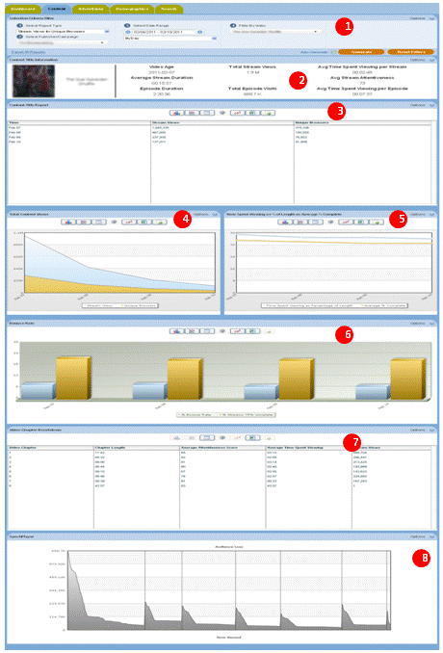
Figure 5: Long-play Video title information in the Content Tab

Selection Criteria Filter
The Selection Criteria Filter panel at the very top of each portal page gives you a detailed way to analyze your video content and ad performance.

Most of the filter choices are in drop-down lists, indicated by a downward arrow to the right of the selection. Date selections will pop up a calendar when you click on the date range text box. Once you have selected the filter lists, then press the Generate Report button at the bottom right-hand side to view the results. Individual filter descriptions are as follows:

Select Report Type
This filter allows you to select the report type that you wish to see.

Select Publisher/Campaign
This filter allows you to select the Publisher/Campaign ID that you wish to see reports for.

Select Date Range
This filter allows you to pick the time period that you are interested in analyzing. Click on the date range text box to interactively select a calendar date range. Once the date range is selected, you can also select a time unit to let you see the charts by Day, Week, Month, or other interval.

Filter By Video
This filter allows you to select a category, sub-category or individual video and/or ad to run reports for.

Excel Export
Excel Export allows you to extract the data in the reports into an Excel Spreadsheet. "Export All Reports" extracts data from every section of the report, and inserts it into separate Tabs in the spreadsheet. The data is truncated to 500 rows on each Tab. An "Export Data" icon is available for each chart, grid, or statistics section. The data is truncated to 32k rows on the individual sections, and it may take a while to return if it is especially large. If have data sets on individual reports which exceed 32K rows please contact you Nielsen Account Manager, who will be happy to assist you with this.

Video Title Information

This report displays a set of high level stats for an individual video title which includes Stream Duration, Episode Duration, the date that the video was first published, the number of times stream was viewed, the number of times episode was viewed, the average time spent viewing an episode, the average time spent viewing a stream and Average Stream Attentiveness.

& Stream Views for Unique Browsers
Stream Views shows the total number of times a video has been started. Unique Browsers are the number of individuals that have started a video at least once during the time interval in the Date Range. For example, if a viewer has visited 7 days in a row, they will be counted once each day in a daily Stream Views chart. Stream Views is always higher than (or equal to) Unique Browsers, as a visitor will often play multiple videos. Note that the sum of these data points will differ from the number of unique browsers in the Content Summary Stats, which is de-duped over the entire period, rather than by unit of drill down (as is the case here)
- Moving your mouse over a data point or bar in a chart will pop up the detail for that point.
- Clicking on a data point or bar in a chart (or on a row in the List view) will drill down to the next level of detail; for example, clicking on a data point for a day will drill down to the hours within that day.
- To go back to the Category or Subcategory, click on the link in the "Path:" above the chart.
- Clicking on an Hourly data point will drill across to a Reach Breakdown report with other information related to reach for that Day.

Average Time Spent Viewing
This report compares the average time spent viewing (including seek backs) as a percentage of overall duration versus the percent complete of a video based on seconds watched. Note that the average time spent viewing can be greater than 100% since a given segment may be watched more than once. Also note that percent complete counts any given second of video play only once. So it is a video's viewing time but not including seek backs.

Content Bounce Rate vs 75% Complete
Bounce Rate and Complete Views is a composite chart to let you know where and when your viewers are leaving the videos. The first bar is the Bounce Rate, the percentage of viewers who leave the video within the first 10 seconds. The second bar shows the viewers who complete 75% or more of the video.
- Moving your mouse over a data point or bar in a chart will pop up the detail for that point.
- Clicking on a data point or bar in a chart (or on a row in the List view) will drill down to the next level of detail; for example, clicking on a data point for a day will drill down to the hours within that day.
- To go back to the Category or Subcategory, click on the link in the "Path:" above the chart.

Video Chapter Breakdown

Chapter Breakdown appears in the event that your piece of content is ‘long form’ (i.e. has more than one segment, two of which are separated by an ad). The ‘chapters’ or segments of your content will appear listed to the left side of the chart and numbered according to the order in which they appeared. You are able to see, by chapter, metrics for length, average attentiveness, average time spent viewing and stream views.

Audience Drop Off

Note: Because the Loss Report is data heavy, and may take some time to load, you will need to click on the ‘Load Chart and Video’ button in order to view the report.
The Audience Loss report shows you visually where in a video that your viewers are leaving. A media player with the video will appear next to the line chart. The beginning value is the number of viewers who have started to watch the video. The progress bar moves forward through the chart line as the video plays, and shows how many viewers are left after each second.

6 The Content Tab
Please click the ‘Content’ tab at the top of the reporting portal. Key components of the Content panel are labeled in the picture below (figure 6) and described thereafter. The remaining reports available in this section are listed and described in the consequent section.

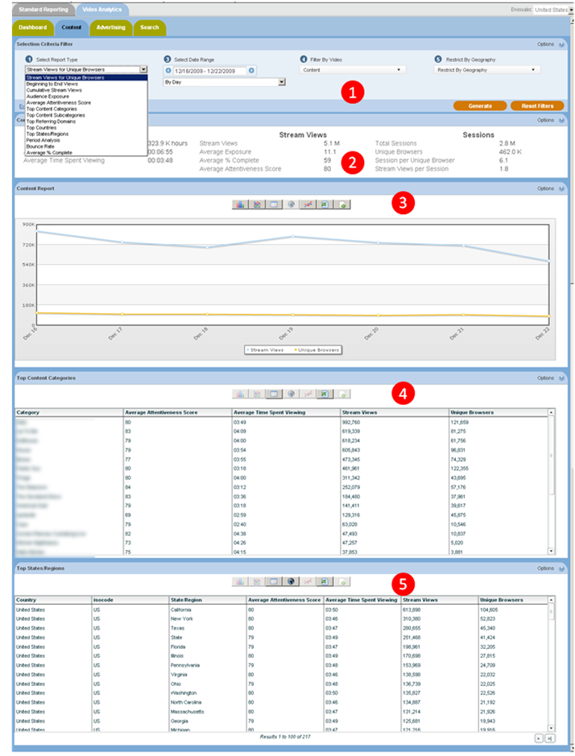

Figure 6: Content panel

Selection Criteria Filter
The Selection Criteria Filter panel at the very top of each portal page gives you a detailed way to analyze your video content and ad performance.
Most of the filter choices are in drop-down lists, indicated by a downward arrow to the right of the selection. Date selections will pop up a calendar when you click on the date range text box. Once you have selected the filter lists, then press the Generate Report button at the bottom right-hand side to view the results. Individual filter descriptions are as follows:

Select Report Type
This filter allows you to select the report type that you wish to see.

Select Publisher/Campaign
This filter allows you to select the Publisher/Campaign ID that you wish to see reports for.

Select Date Range
This filter allows you to pick the time period that you are interested in analyzing. Click on the date range text box to interactively select a calendar date range. Once the date range is selected, then you can also select a time unit to let you see the charts by Day, Week, Month, or other interval.

Filter By Video
This filter allows you to select an individual video and or ad to run reports for. Video content has many different ways of being categorized. For example, a TV show might be organized by Show, then by Season, then by episode. Or TV shows could be categorized by Action, Drama, and Comedy. Nielsen can work with you on how to categorize your content (and Ads) to best represent how you are organized. Once the content is categorized, you can filter all the way down to an individual video or ad. The way Ads are categorized and filtered is very similar to video content. A powerful aspect of the Nielsen reporting system is the ability to see how ads perform against video content, an area we call ad/content interaction.

Restrict By Geography
This filter allows you to break out your viewers based on geographic location. First select a country. A list of the available States or Regions is then available in a list. If you want further detail, select a State or Region, and the available Cities in that area will appear in a subsequent list.

Excel Export
Excel Export allows you to extract the data in the reports into an Excel Spreadsheet. "Export All Reports" extracts data from every section of the report, and inserts it into separate Tabs in the spreadsheet. The data is truncated to 500 rows on each Tab. An "Export Data" icon is available for each chart, grid, or statistics section. The data is truncated to 32k rows on the individual sections, and it may take awhile to return if it is especially large. If have data sets on individual reports which exceed 32K rows please contact you Nielsen Account Manager, who will be happy to assist you with this.

Content Summary Statistics
This report displays summary level statistics for your video content in the areas of Time Spent, Stream Views, and Sessions:

Time Spent Viewing
The amount of video viewed at normal speed in seconds or other appropriate time-based units; if a rewind event occurs during play, Time Spent Viewing may be calculated on total amount of video viewed at normal speed (i.e. including additional amounts of video viewed after rewind.)

Average Session Duration
The average time spent watching one or more videos on a site during a single Viewing Session in seconds. A viewing session is defined as a period of interaction between a visitor's browser and a particular video site, ending when the browser is closed, the user navigates away, or when the user has remained on a site but not had any streaming activity for a 30 minute period of time.

Average Time Spent Viewing
The Total Viewing Time divided by the total number of Stream Views in seconds.

Stream Views
The total number of videos viewed.

Average Exposure
The average number of times a viewer is exposed to a video or ad. Average Exposure gives you an indication of how effective your videos are or how well your ad campaign is progressing. It can also be used to adjust an ad serving policy, if an ad is being seen too frequently (or not enough).

Average % Complete
The average percentage of video viewed continuously at normal speed. If a rewind event occurs during play, percent complete may be calculated on total amount of unduplicated video viewed at normal speed. Each section of video may only be considered once in the calculation. This definition governs the triggering of any “partial play” metrics, such as the common quartile percentages (25%, 50%,75%). Specifically, any partial play reporting must be based on the trigger being activated based on normal viewing speed.

Average Attentiveness Score
The Attentiveness Score provides a single, comprehensive number to measure how your videos are performing. We weight factors such as how long the viewer has watched the video, whether the video or ad is viewable (in focus) by the viewer, and other positive events like turning up the sound, and making the video full screen. We also adjust Attentiveness to account for viewer loyalty (repeat views by the same viewer). The score is a number from 1 (lowest Attentiveness) to 100 (highest Attentiveness).

Total Sessions
A viewing session is defined as a period of interaction between a visitor's browser and a particular video site, ending when the browser is closed, the user navigates away, or when the user has remained on a site but not had any streaming activity for a 30 minute period of time.

Unique Browsers
Unique Browsers are the number of individual visitors that have started a video. (a) In the Summary Statistics at the top of each Report Tab, Unique Browsers are the number of individuals that have viewed a video at least once during the Date Range in the filter. Whether the individual viewer visited 1 time or one 100 times during the Date Range, they will only be counted as one Unique Browser (b) In the detailed Charts (like Stream Views for Unique Browsers) Unique Browsers are the number of individuals that have viewed a video at least once during the time interval in the Date Range. For example, if the Stream Views for Unique Browsers report Date Range is the 1st to the 7th, By Day, the Unique Browsers are the individual visitors counted each day. If a viewer has visited 7 days in a row, they will be counted once each day in the Stream Views

Sessions per Unique
Viewing Sessions divided by the number of Unique Browsers.

Stream Views per Session
Stream Views divided by the number of Viewing Sessions.

Stream Views for Unique Browsers
Stream Views shows the total number of times a video has been started. Unique Browsers are the number of individuals that have started a video at least once during the time interval in the Date Range. For example, if a viewer has visited 7 days in a row, they will be counted once each day in a daily Stream Views chart. Stream Views is always higher than (or equal to) Unique Browsers, as a visitor will often play multiple videos. Note that the sum of these data points will differ from the number of unique browsers in the Content Summary Stats, which is de-duped over the entire period, rather than by unit of drill down (as is the case here).

Top Content Titles

Top Videos shows the most popular content sorted by Reach (default.) You can resort the list by Attentiveness or Attentive Reach by selecting those options from the drop-down list at the top of the report. Attentive Reach is calculated by multiplying Reach by Attentiveness as a percentage. It can help you understand if a video with limited reach may still be very valuable to a subset of your viewers.

You can also click the links within the video information area to display more detailed reports on that video.

Note: Although you may have filtered your data by a specific geographic region please note that the content report still displays All Regions.

Top States/Regions
This report shows you where your audience is located in the world on a state, or region, basis along with a breakdown of stream views, unique browsers, average time spent viewing and average attentiveness score for each audience locale. Isocode is the two character short name for a country as set by the International Organization for Standardization.

Other reports accessible via the Content Tab…….

Audience Exposure
The Audience Exposure report gives you the average number of times a unique browser has played a video or ad. Audience Exposure tells you the frequency with which ads/pieces of content are viewed.
Period Analysis
The Period Analysis report shows you Stream Views broken down by day part (hours of the day). It is an indicator of when the most popular viewing time periods are for your content or ad.
Average Percent Complete
The Average Percent Complete metric gives you an indication of how long viewers are watching your videos and may be an indicator of how compelling the viewers find the video content. Average % Complete is the average percentage of unduplicated video viewed continuously. Each section of the video may only be considered once in the calculation, so Average Percent Complete can never be higher than 100%. Average Time Spent Viewing as a Percentage of Length is measured by the total amount of the video watched divided by the length of the video, expressed as a percentage, so the result can be higher than 100% (if a viewer rewinds and watches a part of the video more than once).
Beginning-to-End Views
This report measures the percentage of viewers who watched the video from the beginning through at least the 95% mark.

Average Attentiveness Score
The Attentiveness Score provides a single, comprehensive number to measure how your videos are performing. We weight factors such as how long the viewer has watched the video, whether the video or ad is viewable (in focus) by the viewer, and other positive events like turning up the sound, and making the video full screen. We also adjust attentiveness to account for viewer loyalty (repeat views by the same viewer). The score is a number from 1 (lowest attentiveness) to 100 (highest attentiveness).
Top Countries
This report shows you where your audience is located in the world on a country by country basis along with a breakdown of stream views, unique browsers, average time spent viewing and average attentiveness score for each audience locale. Isocode is the two character short name for a country as set by the International Organization for Standardization.
Top Referring Domains
Referring Domains shows the top referring web sites to your site sorted by Stream Views (default). This shows the web site that the viewer was on before they watched your video. It helps you understand not only which sites are referring the most traffic to your site, but which sites are referring the viewers that are the most highly engaged. You can resort the list by clicking on any one of the column headers for Referring Domains, Average Attentiveness, Average Time Spent Viewing, Stream Views and Unique Browsers.

7 The Advertising Tab
Video Analytics also reports on ad campaign performance separately from the content that they are played with. Please click the ‘Advertising’ tab at the top of the reporting portal. Key components of the Advertising panel are labeled in the picture below (figure 7) and described thereafter.

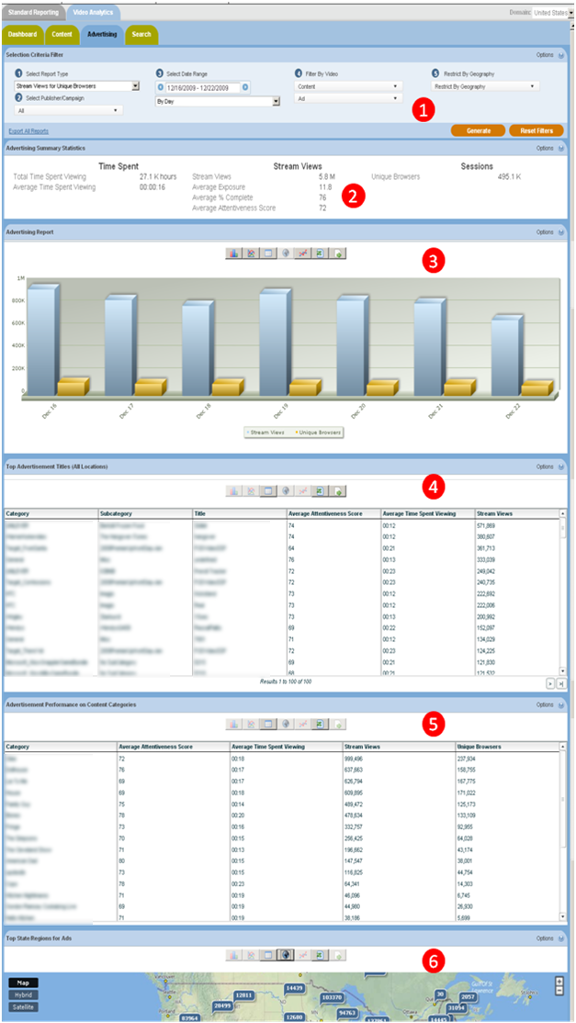
Figure 7: Advertising panel

Selection Criteria Filter
The Selection Criteria Filter panel at the very top of each portal page gives you a detailed way to analyze your video content and ad performance.
Most of the filter choices are in drop-down lists, indicated by a downward arrow to the right of the selection. Date selections will pop up a calendar when you click on the date range text box. Once you have selected the filter lists, then press the Generate Report button at the bottom right-hand side to view the results. Individual filter descriptions are as follows:

Select Report Type
This filter allows you to select the report type that you wish to see.

Select Publisher/Campaign
This filter allows you to select the Publisher/Campaign ID that you wish to see reports for.

Select Date Range
This filter allows you to pick the time period that you are interested in analyzing. Click on the date range text box to interactively select a calendar date range. Once the date range is selected, then you can also select a time unit to let you see the charts by Day, Week, Month, or other interval.

Filter By Video
This filter allows you to select an individual video and or ad to run reports for. Video content has many different ways of being categorized. For example, a TV show might be organized by Show, then by Season, then by episode. Or TV shows could be categorized by Action, Drama, and Comedy. Nielsen can work with you on how to categorize your content (and Ads) to best represent how you are organized. Once the content is categorized, you can filter all the way down to an individual video or ad. The way Ads are categorized and filtered is very similar to video content. A powerful aspect of the Nielsen reporting system is the ability to see how ads perform against video content, an area we call ad/content interaction.

Restrict By Geography
This filter allows you to break out your viewers based on geographic location. First select a country. A list of the available States or Regions is then available in a list. If you want further detail, select a State or Region, and the available Cities in that area will appear in a subsequent list.

Excel Export
Excel Export allows you to extract the data in the reports into an Excel Spreadsheet. "Export All Reports" extracts data from every section of the report, and inserts it into separate Tabs in the spreadsheet. The data is truncated to 500 rows on each Tab. An "Export Data" icon is available for each chart, grid, or statistics section. The data is truncated to 32k rows on the individual sections, and it may take awhile to return if it is especially large. If have data sets on individual reports which exceed 32K rows please contact you Nielsen Account Manager, who will be happy to assist you with this.

Content Summary Statistics
This report displays summary level statistics for your videos ads in the areas of Time Spent v, Stream Views, and Sessions:

Time Spent Viewing
Represents the total time spent viewing across the period selected

Average Time Spent Viewing
The Total Viewing Time divided by the total number of Stream Views in seconds.

Stream Views
The total number of videos viewed.

Average Exposure
The average number of times a viewer is exposed to a video or ad. Average Exposure gives you an indication of how effective your videos are or how well your ad campaign is progressing. It can also be used to adjust an ad serving policy, if an ad is being seen too frequently (or not enough).

Average % Complete
The average percentage of video viewed continuously at normal speed. If a rewind event occurs during play, percent complete may be calculated on total amount of unduplicated video viewed at normal speed. Each section of video may only be considered once in the calculation. This definition governs the triggering of any “partial play” metrics, such as the common quartile percentages (25%, 50%,75%). Specifically, any partial play reporting must be based on the trigger being activated based on normal viewing speed.

Attentiveness Score
The Attentiveness Score provides a single, comprehensive number to measure how your videos are performing. We weight factors such as how long the viewer has watched the video, whether the video or ad is viewable (in focus) by the viewer, and other positive events like turning up the sound, and making the video full screen. We also adjust Attentiveness to account for viewer loyalty (repeat views by the same viewer). The score is a number from 1 (lowest Attentiveness) to 100 (highest Attentiveness).

Unique Browsers
Unique Browsers are the number of individual visitors that have started a video. (a) In the Summary Statistics at the top of each Report Tab, Unique Browsers are the number of individuals that have viewed a video at least once during the Date Range in the filter. Whether the individual viewer visited 1 time or one 100 times during the Date Range, they will only be counted as one Unique Browser (b) In the detailed Charts (like Stream Views for Unique Browsers) Unique Browsers are the number of individuals that have viewed a video at least once during the time interval in the Date Range. For example, if the Stream Views for Unique Browsers report Date Range is the 1st to the 7th, By Day, the Unique Browsers are the individual visitors counted each day. If a viewer has visited 7 days in a row, they will be counted once each day in the Stream Views

Stream Views for Unique Browsers
Stream Views shows the total number of times a video has been started. Unique Browsers are the number of individuals that have started a video at least once during the time interval in the Date Range. For example, if a viewer has visited 7 days in a row, they will be counted once each day in a daily Stream Views chart. Stream Views is always higher than (or equal to) Unique Browsers, as a visitor will often play multiple videos. Note that the sum of these data points will differ from the number of unique browsers in the Content Summary Stats, which is de-duped over the entire period, rather than by unit of drill down (as is the case here).

Top Advertising Titles

Top Videos shows the most viewed ads sorted by Reach (default.) You can resort the list by Attentiveness or Attentive Reach by selecting those options from the drop-down list at the top of the report. Attentive Reach is calculated by multiplying Reach by Attentiveness as a percentage. It can help you understand if a video with limited reach may still be very valuable to a subset of your viewers.

You can also click the links within the video information area to display more detailed reports on that video.

Note: Although you may have filtered your data by a specific geographic region please note that the content report still displays All Regions.

Advertisement Performance on Content Categories
This report shows how an ad performs with different categories of content. You can use this report to find the best match for your viewers, and optimize engagement and click-through rates. This report can be sorted by any of the columns.

Top States/Regions
This report shows you where your audience is located in the world on a state, or region, basis along with a breakdown of stream views, unique browsers, average time spent viewing and average attentiveness score for each audience locale. Isocode is the two character short name for a country as set by the International Organization for Standardization.

Other reports accessible via the Advertising Tab…….

Top Referring Domains
Referring Domains shows the top referring web sites to your site sorted by Stream Views (default). This shows the web site that the viewer was on before they watched your video. It helps you understand not only which sites are referring the most traffic to your site, but which sites are referring the viewers that are the most highly engaged. You can resort the list by clicking on any one of the column headers for Referring Domains, Average Attentiveness, Average Time Spent Viewing, Stream Views and Unique Browsers.
Audience Exposure
This report gives you the average number of times a unique browser has played a video or ad. Audience Exposure tells you the frequency with which ads/pieces of content are viewed.
Average Attentiveness Score
The Attentiveness Score provides a single, comprehensive number to measure how your videos are performing. We weight factors such as how long the viewer has watched the video, whether the video or ad is viewable (in focus) by the viewer, and other positive events like turning up the sound, and making the video full screen. We also adjust attentiveness to account for viewer loyalty (repeat views by the same viewer). The score is a number from 1 (lowest attentiveness) to 100 (highest attentiveness).
Beginning-to-End Views
This report measures the percentage of viewers who watched the video from beginning to end (at least 95%).
Content Bounce Rate vs 75% Complete
Bounce Rate and Complete Views is a composite chart to let you know where and when your viewers are leaving the videos. The first bar is the Bounce Rate, the percentage of viewers who leave the video within the first 10 seconds. The second bar shows the viewers who complete 75% or more of the video.
- Moving your mouse over a data point or bar in a chart will pop up the detail for that point.
- Clicking on a data point or bar in a chart (or on a row in the List view) will drill down to the next level of detail; for example, clicking on a data point for a day will drill down to the hours within that day.
- To go back to the Category or Subcategory, click on the link in the "Path:" above the chart.

8 The Demographics Tab
Please click the ‘Demographics’ tab at the top of the reporting portal. Key components of the Demographics panel are labeled in the picture below (figure 8) and described thereafter. The remaining reports available in this section are listed and described in the consequent section.

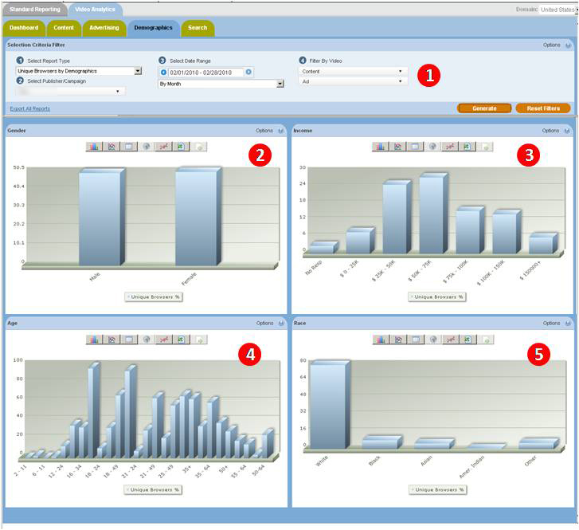
Figure 8: Demographics panel

Selection Criteria Filter
The Selection Criteria Filter panel at the very top of each portal page gives you a detailed way to analyze your video content and ad performance.
Most of the filter choices are in drop-down lists, indicated by a downward arrow to the right of the selection.
Note: Because the demographic comps available in Video Analytics are sourced from the RDD/Online Panel these are currently only available on a monthly basis. The data for the prior month will populate on the same day the data becomes available in VideoCensus (normally between the 8th and 10th of the following month).
Once you have selected the filter lists, then press the Generate Report button at the bottom right-hand side to view the results. Individual filter descriptions are as follows:

Select Report Type
This filter allows you to select the report type that you wish to see.

Select Publisher/Campaign
This filter allows you to select the Publisher/Campaign ID that you wish to see reports for.

Filter By Video
This filter allows you to select an individual video and or ad to run reports for. Video content has many different ways of being categorized. For example, a TV show might be organized by Show, then by Season, then by episode. Or TV shows could be categorized by Action, Drama, and Comedy. Nielsen can work with you on how to categorize your content (and Ads) to best represent how you are organized. Once the content is categorized, you can filter all the way down to an individual video or ad. The way Ads are categorized and filtered is very similar to video content. A powerful aspect of the Nielsen reporting system is the ability to see how ads perform against video content, an area we call ad/content interaction.
The following rules apply when using the filter drop downs on this tab. When the charts first populate upon arrival at the panel you are seeing data for content only. If you select a particular category, subcategory or creative via the ‘Ad’ drop down (and hit generate) you will then see data for that ad category, subcategory or creative only. Likewise, if you select a particular category, subcategory or stream via the ‘Content’ drop down (and hit generate) you will then see data for that content category, subcategory or creative only. In order to see the demographic comps of a piece, or category, of content AND a piece, or category, of advertising you can select them both (and hit generate), this will show you the demographics of the audience who saw the two in combination.
Note: In certain instances you may find that applying certain filters and then hitting the generate button results in the following message. “Not enough sample size to generate report data. If possible, use less restrictive filter conditions”. This indicates that the particular slice of data you wish to see has not been viewed by enough Nielsen panelists for us to reliably report on the results.

Excel Export
Excel Export allows you to extract the data in the reports into an Excel Spreadsheet. "Export All Reports" extracts data from every section of the report, and inserts it into separate Tabs in the spreadsheet. The data is truncated to 500 rows on each Tab. An "Export Data" icon is available for each chart, grid, or statistics section. The data is truncated to 32k rows on the individual sections, and it may take awhile to return if it is especially large. If have data sets on individual reports which exceed 32K rows please contact you Nielsen Account Manager, who will be happy to assist you with this.

Gender
Use the Select Report Type drop down in the Selection Criteria Filter to view Stream Views, Unique Browsers or Attentiveness Score across gender breaks.

Income
Use the Select Report Type drop down in the Selection Criteria Filter to view Stream Views, Unique Browsers or Attentiveness Score across income breaks.

Age
Use the Select Report Type drop down in the Selection Criteria Filter to view Stream Views, Unique Browsers or Attentiveness Score across age breaks.

Race
Use the Select Report Type drop down in the Selection Criteria Filter to view Stream Views, Unique Browsers or Attentiveness Score across race breaks.

9 The Search Tab
The video search feature allows a user to search for and display video titles which match the specified search query text. Users can then select links on the individual video to display more detailed reports on that aspect of the video.

Note: The search engine only operates using complete words. If your video is titled ‘dramaqueen’ a search for ‘drama’ or ‘queen’ will not return any results.

Special operators for search can be used to narrow your search results:

1. operator AND:
hello & world
hello + world

2. operator OR:
hello | world

3. operator NOT:
hello -world
hello !world

